Master of Science Program in Economics

Orientation Program 2018

Date | Topic | Time | Place | Responsible Person
Friday  October 5th | Welcome to those students already in Freiburg.  General Information by Program Coordinator and Student Union. | 13:00 | Room 2330 KG2 | Program Coordination
 | Welcome days for new international students by the international office of the University of Freiburg  (registration required) | 14:00 | Audimax KG2 | International Office
Monday  October 8th | Math Prep Course, Lecture 1 | 10:00-12:00  14:00-17:00 | HS 3118  HS 3118 | Marjola Terpollari
 | Meet & Talk with 2nd Year Students | 17:00 | Warsteiner Galerie | Student Union
Tuesday  October 9th | Math Prep Course, Tutorial 1: Group 1  Group 2 | 10:00-12:00  14:00-16:00 | HS 3118  HS 3118 | Marjola Terpollari
 | IT Services for Students Presentation | 17:00-17:30 | HS3118 | Markus Rosenfelder
Wednesday  October 10th | Math Prep Course, Lecture 2 | 10:00-12:00  14:00-17:00 | HS 3118  HS 3118 | Marjola Terpollari
Thursday  October 11th | Math Prep Course, Tutorial 2: Group 1  Group 2 | 10:00-12:00  14:00-16:00 | HS 3118  HS 3118 | Marjola Terpollari
Friday  October 12th | Math Prep Course, Lecture 3 | 10:00-12:00  14:00-17:00 | HS 3118  HS 3118 | Marjola Terpollari

 | Official Beginning of the Semester
Monday  October 15th | Lecture Adv. Macroeconomics I |  | 9:00-12:00 | HS 3219
 | Official Welcome to the program:  Program Director, Profile Directors, Program Coordinator, Student Union |  | 14:00-15:00 | Audimax KG2 | Program Coordination
 | Official Reception: Coffee, Tea & Pastries |  | 15:00-16:00 | Audimax  KG2
 | Group Photo |  | 16:00 |  | Student Union
 | Guided tours with 2nd year students |  | 16:30 | Café Europa | Student Union
 | Meet & Talk with 2nd year students |  | 18:00 | Schlossberg Biergarten | Student Union
Tuesday  October 16th | Lecture Computational Economics |  | 12:00-14:00 | HS 3044
 | Math Prep Course, Tutorial 3: Group 1  Group 2 |  | 14:00-16:00  16:00-18:00 | HS 3118  HS 3118 | Marjola  Terpollari
Wednesday  October 17th | Lecture Economic Policy & Public Choice |  | 10:00-12:00 | HS 2121
 | Math Prep Course, Lecture 4 |  | 14:00-16:00  16:00-18:00 | R4 Peterhof  HS 3044 | Marjola  Terpollari
 | Guided tour to the Uniseum |  | 12:15-13:30 | Café Europa | Student Union
Thursday  October 18th | Lecture Adv. Microeconomics I |  | 08:00-10:00 | HS 2121
 | Math Prep Course, Tutorial 4: Group 1  Group 2 |  | 14:00-16:00  16:00-18:00 | R01 042  HS 1098 | Marjola  Terpollari
 | Kick-off-Event Intercultural Mentoring Program (registration required) |  | 18:00-19:30 |  | Intercultural Mentoring
Friday  October 19th | Math Prep Course, Lecture 5 |  | 09:00-11:00  11:00-13:00 | HS 1032  HS 1032 | Marjola  Terpollari
 | Math Prep Course, Tutorial 5: Group 1  Group 2 |  | 14:00-16:00  16:00-18:00 | HS 3044  HS 3044 | Marjola  Terpollari
Saturday  October 20th | Orientation Weekend Schluchsee  registration deadline 8th October  Presentations:  - Program Structure and Regulations: MEP Coordinator – Antonio Farfán  - Structure of the Department of Economics: MEP Coordinator & Student Union – Amanda Benecke  - Tips & Tricks for your studies: Student Union – Lucas Finke  - German Academic Culture: MEP Coordinator - Antonio Farfán
Sunday
October 21th

Friday  October 26th | MEP Party – Semester Opening | Peterhofkeller | Student Union

Types of activities:

In yellow | Official Events organized by the Faculty of Economics
In orange | Activities organized by 2nd year students – Student Union  Registration required for the Orientation Weekend at Schluchsee: MEP.studentunion@gmail.com
In red | Activities organized by the International Office and the Intercultural Mentoring Program.  Require previous registration until September 15th  For additional information and registration please check attachment and:  http://www.studium.uni-freiburg.de/en/student-services/beginning-students/welcome-days?set_language=en  and  http://www.mentoring.uni-freiburg.de/intercultural
In green | Official lectures (during the first week there are no tutorials)  No registration required
In blue | Math Preparation Course  No registration required

How to find the different lecture rooms?

1: KG1 Kollegiengebäude 1: Rooms starting with 1
2: KG2 Kollegiengebäude 2: Rooms starting with 2, like 2330, Audimax, or HS2006
3: KG3 Kollegiengebäude 3: Rooms starting with 3, like HS3118
8: Library (UB)
10: Uniseum
11: Peterhof

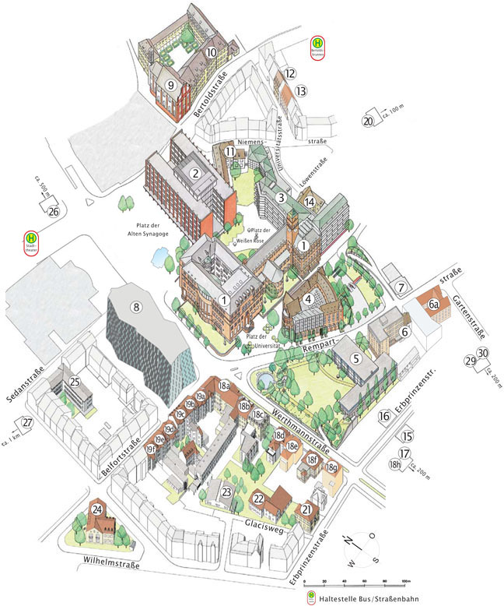

Stand 17.8.2018

